PICTURES TAKEN AT THE JIV TO EROTON EXPLORATION AND PRODUCTION COMPANY LIMITED.

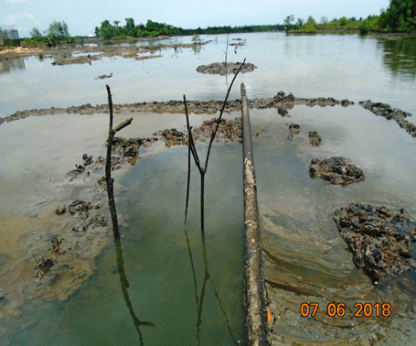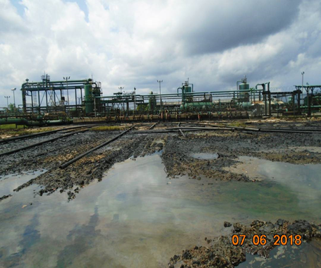
Overview of the Cawthorne Channel 1 oil The 9S 4’’ flow line in which the oil spill spill site. ocurred. The location of the sticks’ are
the spill points. Muds were heaped
around the spill points to curtail further
spread of the oil.

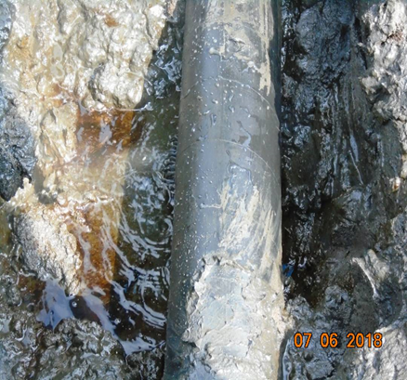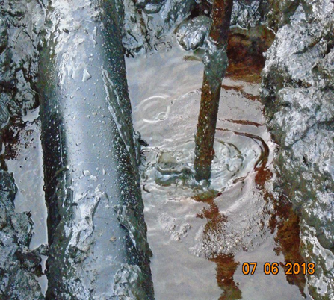

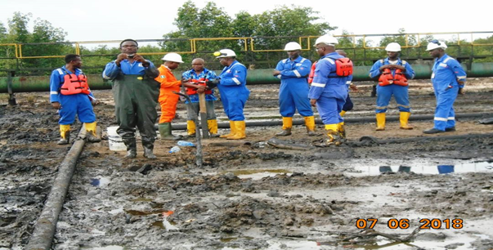
The JIT at the oil spill site

